The Rover; A Theatrical Play
Student’s Name
Institutional Affiliation

Welcome
The Rover; A Theatrical Play
Get your nickers on for the production with an uplifting score of drama and passion and a whole lot of material. We have it all, from Spanish noblewomen, exotic Spanish courtesan, Englishmen both wealthy and not as much. Witness an ancient view on romance, love and matrimony in a colorful demonstration.
Directed and choreographed by none other than David Geffen in the Clubbed Thumb theatre with a thrilled cast line-up. Set in the mid ‘60s; come bear witness to the tales of two noblewomen in their quest for love besides their brother’s wishes, the Spanish suiters with their eyes set on specific targets, glimpses of passion and the tales of English men and their pursuits in a foreign land. Fight scenes, pirates, rape, gender roles and female agency, unrequited love, brutality and many more to be explored.
Grab a drink, find your seats, and get ready for the experience of a lifetime. Don’t forget to shape up your Baltimore experience. With the very best of wishes, welcome all. Bring a friend.
Venue; Clubbed Thumb theatre
Date; 12th April 2019
Time; 2300hours GMT
Tickets; Online or Clubbed Thumb theatrical retail shops
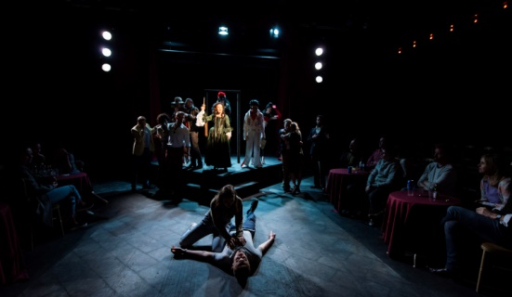
The casting in preparation on set

The Englishmen and the fights that ensue
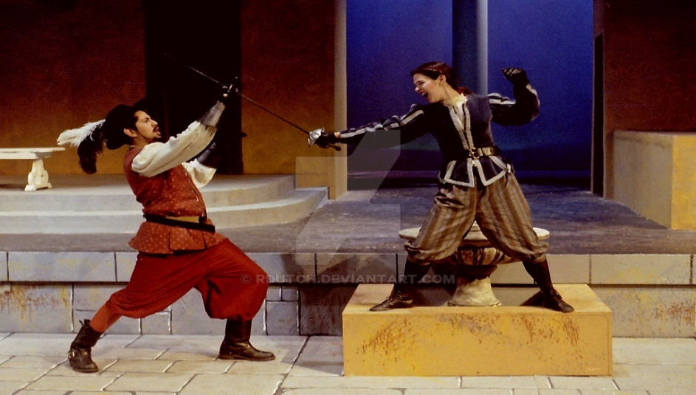
Brave Florinda

